

**Worksheet: STE.1.1.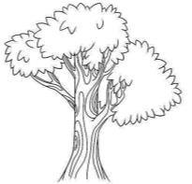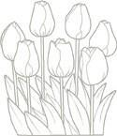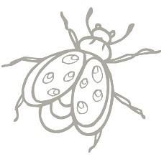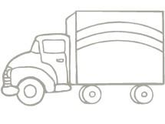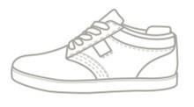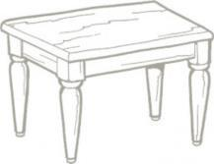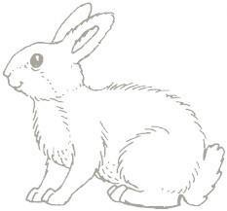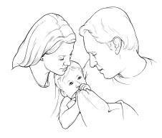3**

Name: __________________________________________________________

Living Non-Living